GIBSON PRIMARY SCHOOL
Principal: Mr K Sterritt
64 Old Mountfield Road, Omagh, Co Tyrone, BT79 7EG
Tel: (028) 82244552 Website: www.gibsonps.co.uk E Mail: ksterritt616@c2kni.net

25 August 2020

Dear Parent

School dinners will be served in our Dining Hall and Assembly Hall from Tuesday 1 September. We will have two separate lunch breaks and have designated areas set out in both halls to ensure pupils stay within their bubbles at all times. I believe providing hot dinners is an important for our pupils and have attached an updated menu on the school website which can be accessed via www.gibsonps.co.uk/parents/school-dinner-menu/

We will once again be taking both BOOKINGS and PAYMENTS for school dinners through our online booking system which will go live this Friday afternoon (28 August 2020). This means we are unable to accept cash for dinners.

Passwords for eduspot (www.eduspot.co.uk) remain unchanged. This will give you access to your SchoolMoney account where you can pay for your child’s school dinners. Please note all pupils taking school dinners MUST book online. If your child is entitled to Free School Meals these should also be ordered through the system although there will be no charge.

In order to update our system with those entitled to free meals it is essential that we have received official confirmation from EA regarding free meal eligibility. If you have not applied or have yet to receive confirmation you will have to pay until we are notified by EA.

I have included a basic overview of the cashless payment system as it is quite some time since any of us have used it. If you are experiencing difficulties with logging on, please contact the school office. Please note you should be able to log on any time, however you will not be able to book meals until Friday afternoon.

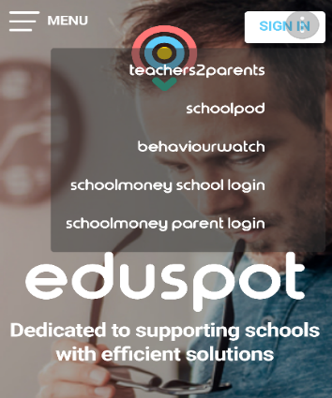
Cashless Payment System Instructions
- Go to www.eduspot.co.uk . This will bring you to the parent login page.

- Click on Sign In (top right corner)

- Click School Money Parent Login

- School dinners will need to be paid by midnight of the day before. Ideally payments are made at the start of the week no later than midnight on Sunday.

- Once again it will be possible to pay up to a maximum of 4 weeks in advance from October. Until then we will operate weekly.
Your support in this matter is appreciated.

Yours sincerely

K Sterritt (Mr)
Principal

